Department of Information Technology
Academic Year: 2024-25 Name of Student: Khushi anchalia
Class / Branch / Div: TE- IT B Roll No.1
Subject: MAD & PWA Lab Date of Submission: 9/4/26 Name of Instructor:Prof. Manjusha Kashilkar

Experiment No.:11
Aim: To implement deployment of Ecommerce PWA to GitHub Pages.
Prerequisites:HTML5, CSS3, JS.

Software: VS code.

Problem Statement:. To Create a responsive User Interface for a website layout using media Queries.
Code:
Index.html
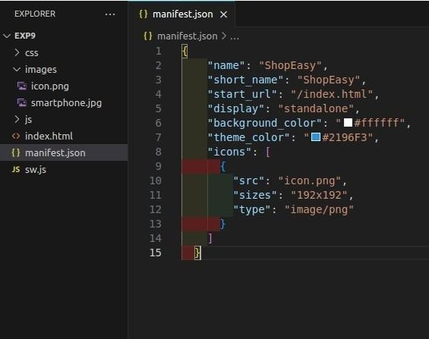

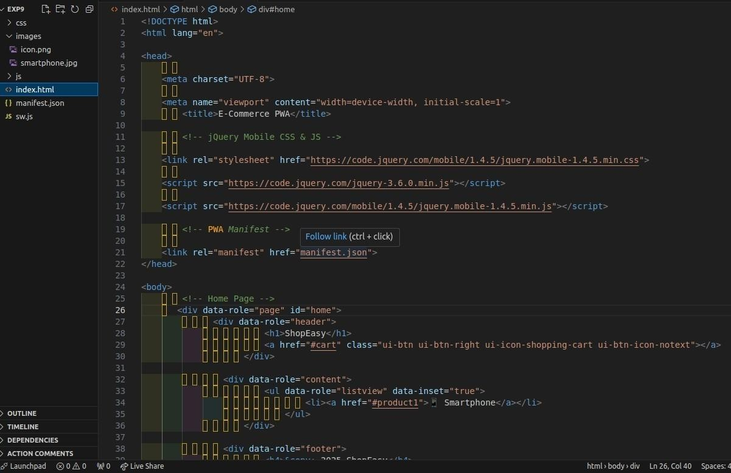
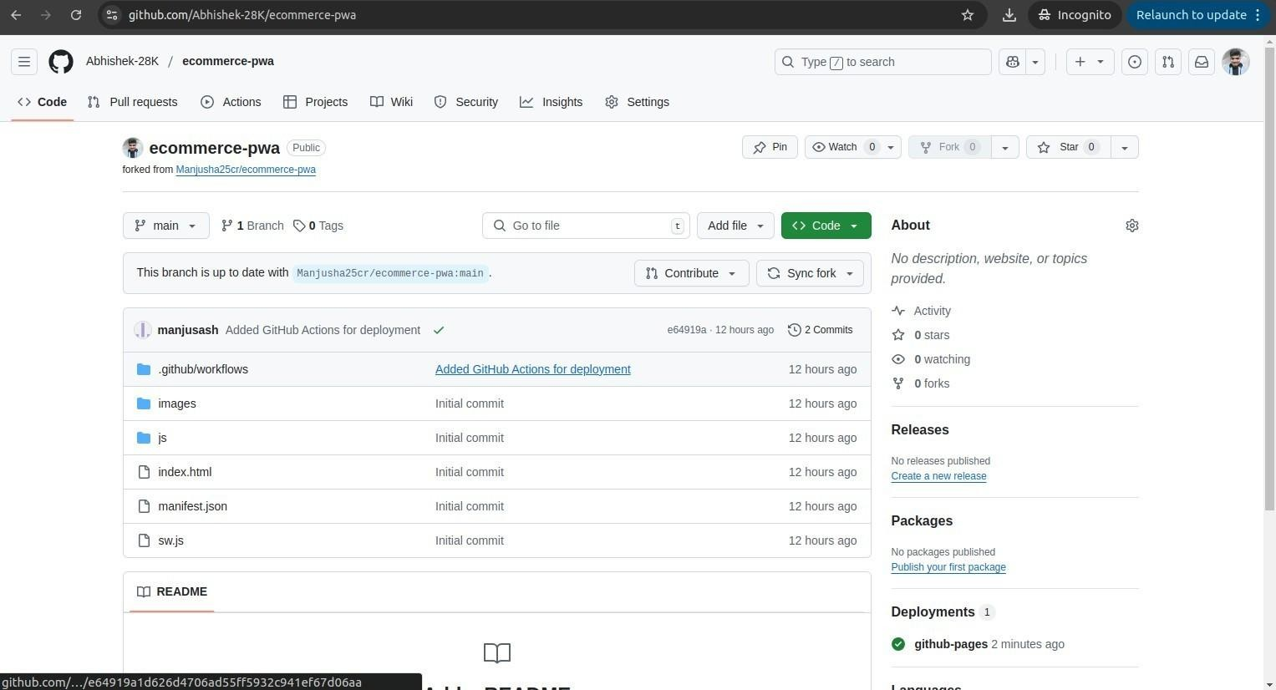

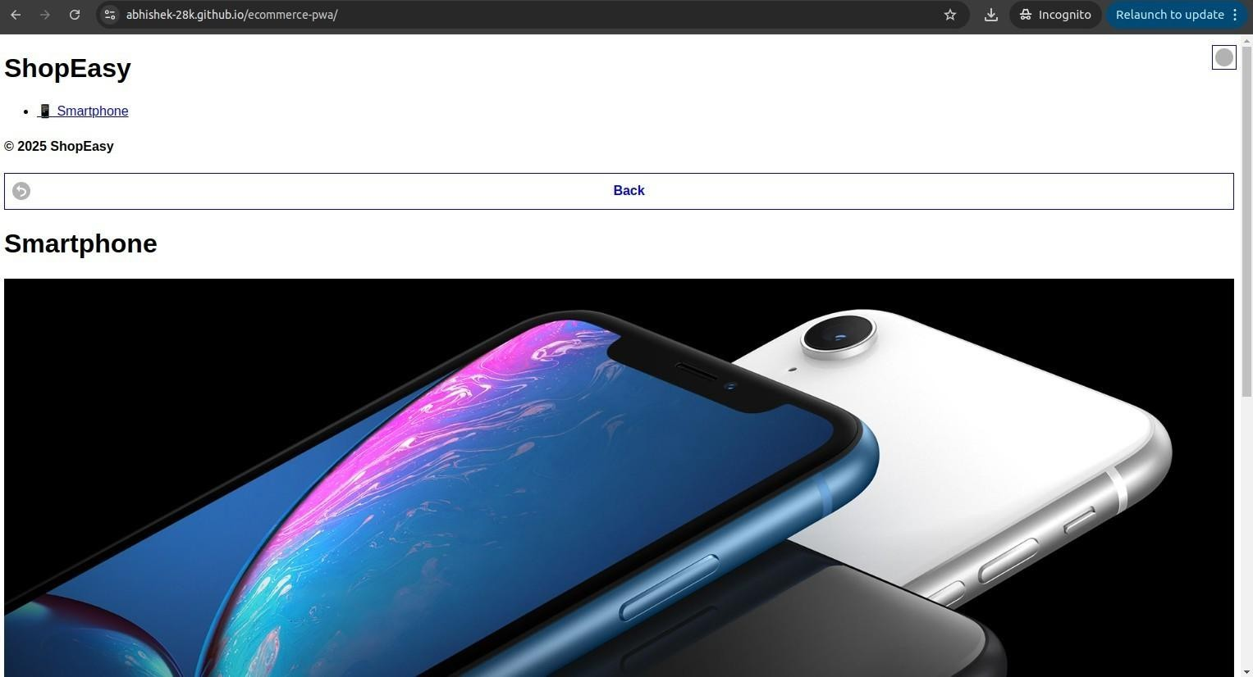

Conclusion: In this experiment we have implement deployment of Ecommerce PWA to GitHub Pages.

